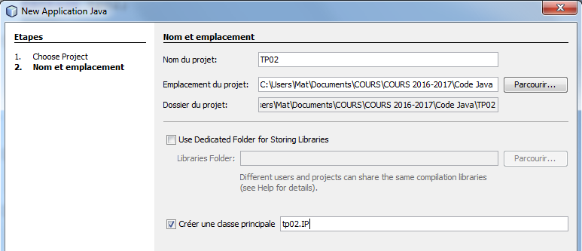

 Set as main project

/*

* To change this license header, choose License Headers in Project Properties.

* To change this template file, choose Tools | Templates

* and open the template in the editor.

*/

package tp02;

/**

*

* @author Mat

*/

public class IP {

/**

* @param args the command line arguments

*/

public static void main(String[] args) {

// TODO code application logic here

}

}

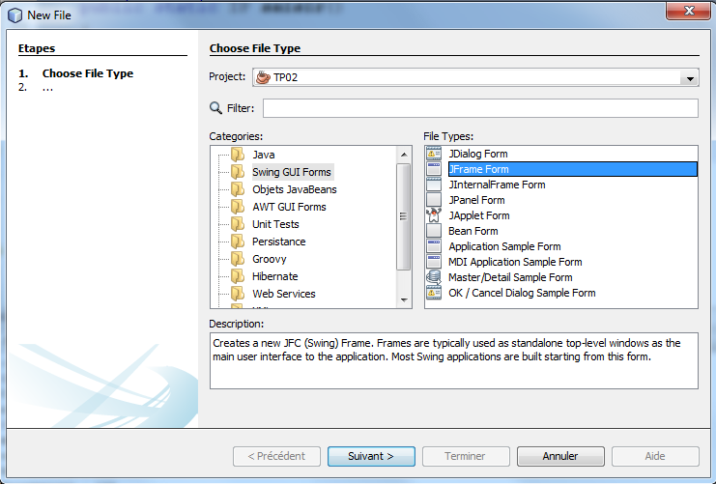

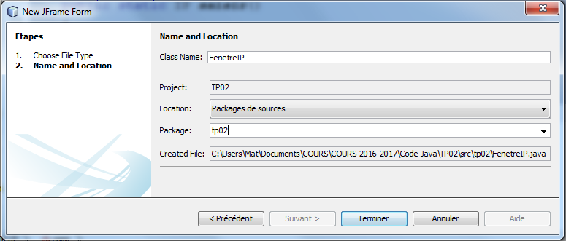

private void jButton1ActionPerformed(java.awt.event.ActionEvent evt) {

// TODO add your handling code here:

// récupération du texte saisi dans le champ de texte txtOctet1

String octet1Saisi = txtOctet1.getText();

JOptionPane jop1 = new JOptionPane();

//Boîte du message d'information

jop1.showMessageDialog(null, octet1Saisi, "Information", JOptionPane.INFORMATION_MESSAGE);

}